PERSONAL INFORMATION | Iris Lobaš Kukavičić
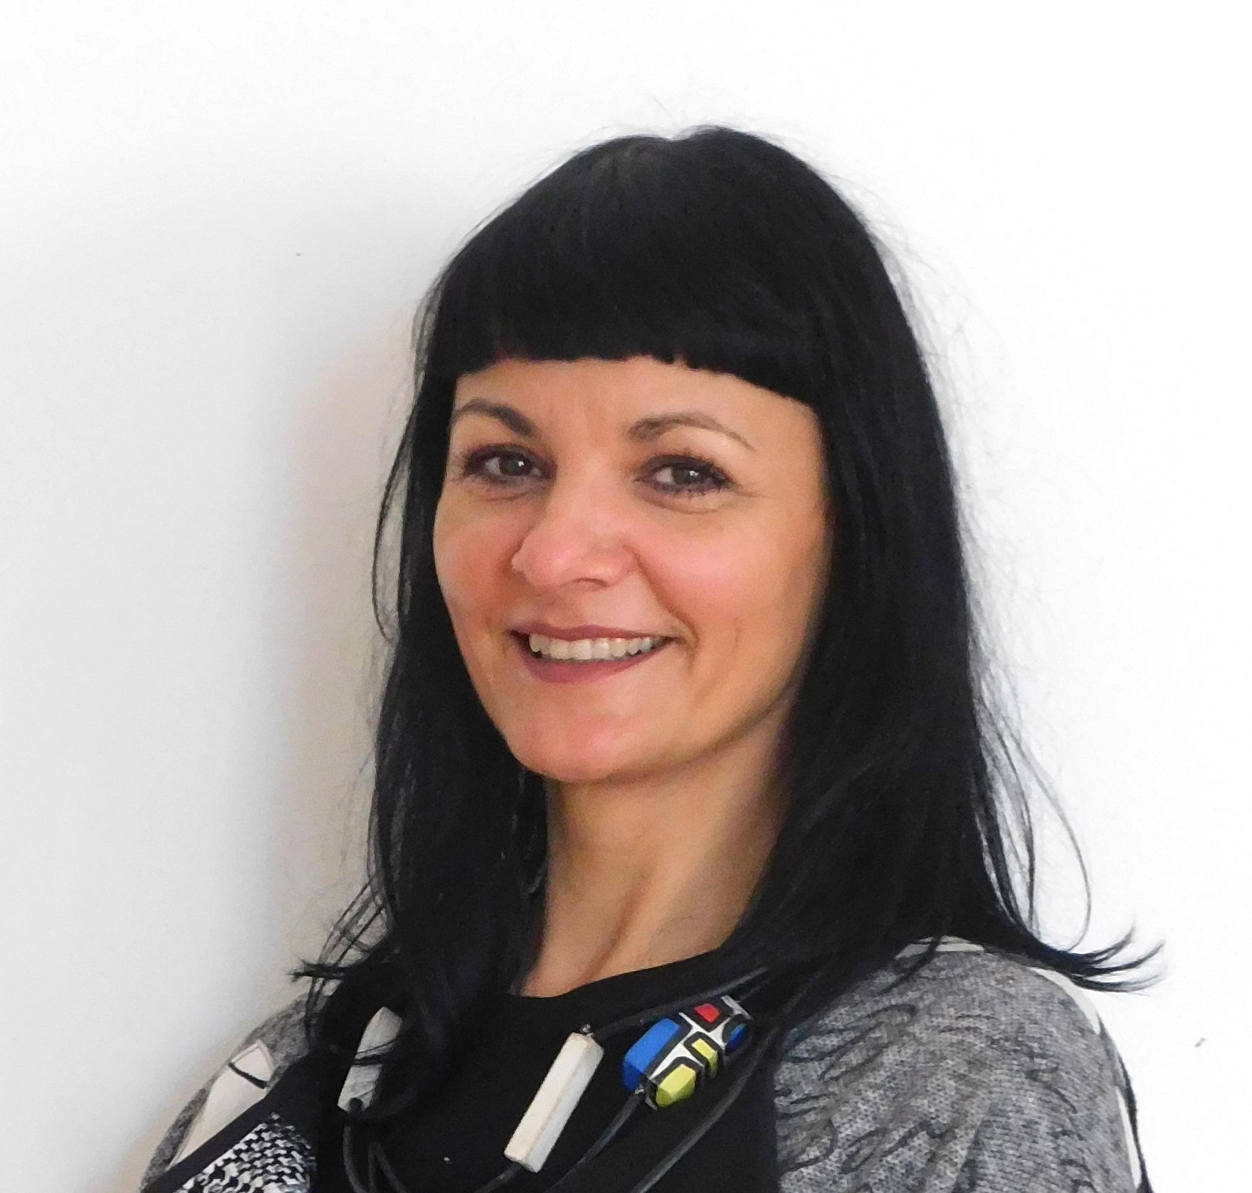 |   University of Dubrovnik, Arts and Restoration Department  Branitelja Dubrovnika 41, Dubrovnik, Croatia

Iris.lobas@unidu.hr, iris.lobas@gmail.com

https://www.iris-lobas-kukavicic.com/en/
 | Sex female | Date of birth 19/06/1976 | Nationality Croatian

WORK EXPERIENCE

03/2018-present  06/2006-03/2018  10/2005-06/2006  09/2004-06/2006 | Assistant Professor at the Department of Art and Restoration, University of Dubrovnik
Assistant at the Department of Art and Restoration, University of Dubrovnik
Associate lecturer at the Department of Art and Restoration, University of Dubrovnik
Art professor, Elementary school Marin Držić, Dubrovnik

EDUCATION AND TRAINING

10/1995-06/2001  10/2006-06/2008  10/2012-06/2016 | Academy of Fine Arts of the University of Zagreb, undergraduate studies of Art Education
10/1995-06/2001  10/2006-06/2008  10/2012-06/2016 | Academy of Fine Arts of the University of Mostar, post-graduate study Ars sacra
10/1995-06/2001  10/2006-06/2008  10/2012-06/2016 | Academy of Fine Arts of the University of Mostar, PhD, Ars sacra

ART PROJECTS

PUBLIC SCULPTURES/  ART INSTALLATIONS  SOLO EXHIBITIONS | - 2017. GAME AND GAMES, international terminal C, Dubrovnik Airport  - 2014. THE SITTING FIGURE, the Hartmann administrative building, Copenhagen, Denmark  - 2002. A GROUP OF SCULPTURES, Hartmann-Bilokalnik factory surroundings, Koprivnica  - 2001. THE DANCER, Jarun lake (club Aquarius), Zagreb  - 2017 TEN ENCOUNTERS, DMP gallery, Museum of Modern Art Dubrovnik, Dubrovnik  - 2017 A CONVINCING EXPRESSION AND TESTIMONY, “Slavko Kopač“ gallery, Vinkovci Municipal Museum, Vinkovci  - 2016 A STROLL AROUND DUBROVNIK, GKS gallery, Metković  - 2016 A PhD dissertation show, FAA gallery Široki Brijeg, Široki Brijeg  - 2010 ARS SACRA, Gallery of the Monastery of Our Lady of Health, Split  - 2010 A STROLL AROUND DUBROVNIK, Gallery Sebastian, Dubrovnik

          - 2010 BIG BLUE, Collegium Artisticum, Sarajevo
          - 2010 BIG BLUE, The Franciscan gallery, Široki Brijeg
          - 2008 ARS SACRA, The Franciscan gallery (master degree show), Široki Brijeg
          - 2008 BIG BLUE, Palace Sponza, Dubrovnik
          - 2007 BIG BLUE, Koprivnica city gallery, Koprivnica
          - 2006 ACI marina Korčula gallery, Korčula
          - 2006 The gallery of Orebić maritime museum, Orebić
          - 2005 Gallery LERO, Dubrovnik
          - 2004 GAME, Gallery VN, Zagreb
          - 2004 GAME AND GAMES, Croatian Heritage Foundation gallery, Metković
          - 2004 THE DUBROVNIK PUZZLE, Art Gallery Klarisa, Dubrovnik
          - 2003 IRIS LOBAŠ: MUSICAL, Art Gallery Klarisa, Dubrovnik
          - 2002 GAME AND GAMES, Gallery Ranjina, Dubrovnik

GROUP EXHIBITIONS

          - 2017 CHRISTMAS JOY, Franciscan gallery, Široki Brijeg
          - 2017 DUBROVNIK ARTISTIC MOMENT 3, Museum of Modern Art Dubrovnik, Dubrovnik
          - 2016 The Christmas light, Old Town Hall, Split
          - 2016 St. Dominic in contemporary art, Dominican monastery, Dubrovnik
          - 2016 12 artists and Saint Blaise, Marin Držić Theatre , Dubrovnik
          - 2015 We to you as you to us, visual artists about Marin Držić, House of Marin Držić, Dubrovnik
          - 2014 St. Blaise in contemporary art, Sebastian Gallery, Dubrovnik
          - 2012 St. Blaise in the past and the present, Rector’s palace, Dubrovnik
          - 2011 Pope John Paul II – in the eye of Dubrovnik artists, Dubrovnik
          - 2011 Dubrovnik Artists Fundraising Exhibition, San Francisco, Los Angeles, Las Vegas, USA
          - 2010 Biennale “THE MEDITERRANEAN 2010“, Milesi palace, Split
          - 2010 SUB DOCUMENTA, Skenderija, Sarajevo
          - 2008 DUBROVNIK ARTISTIC MOMENT 2, Museum of Modern Art Dubrovnik, Dubrovnik
          - 2008 Ars Sacra, Gallery of Vinkovci Academy of Fine Arts, Vinkovci
          - 2008 Marin Držić in the works of academic painters, Convent of St. Claire, Dubrovnik
          - 2007 The private and the public ( award winning work “Ants”), Široki Brijeg
          - 2007 EASTER, Sponza palace, Dubrovnik
          - 2006 Dubrovnik and the sea 2006, University of Dubrovnik, Dubrovnik
          - 2005 NECKTIES, Dubrovnik house, Dubrovnik
          - 2005 NECKTIES, Mala gallery, Zagreb
          - 2005 NECKTIES, Vinkovci Municipal Museum, Vinkovci
          - 2006 NECKTIES, City lodge, Zadar
          - 2005 HOMMAGE TO SALVADOR DALI, FER gallery, Zagreb
          - 2004 DUBROVNIK ARTISTIC MOMENT, Museum of Modern Art Dubrovnik, Dubrovnik
          - 2004 PROJECT 01, 02, 03, Močvara gallery, Zagreb
          - 2003 ALILOVCI 2003, City Museum Požega, Požega
          - 2002 SYRUP OF LIFE , Močvara gallery, Zagreb
          - 2002 HARTMANN- BILOKALNIK, Podravska bank, Koprivnica
          - 2002 NEW FRAGMENTS, SC gallery, Zagreb
          - 2001 ZDERZENIA, The International Festival of Theatre and Visual Arts, Tczew, Poland
          - 2001 SELF-PORTRAIT, AquariusNet caffe, Zagreb
          - 2001 Urban festival, Zagreb
          - 2001 CROSSROAD, Art pavilion, Zagreb
          - 2001 PASSIONIC HERITAGE, Mimara Museum, Zagreb
          - 1999 BECAUSE I AM SAND, TIME AND OPEN HAND PALM DROP, passionic heritage,
          - Gallery Zvonimir, Zagreb
          - 1999 3rd festival of the University of Zagreb, exhibition of the Academy of Fine Arts (AFA)
          - students, SC gallery, Zagreb
          - 1998 SAMOBOR AFA VUKOVAR, Vukovar Municipal Museum, Vukovar
          - 1998 I AM JOYFUL WHILE I SUFFER FOR YOU... passionic heritage, Klovićevi Dvori gallery,
          - Zagreb
          - 1997 Exhibition of AFA students, art colony Samobor barracks, Gallery Samobor, Samobor
PROJECTS

- 2020 ‘’recycled ART’’, a project achieved within the Days of Creative and Cultural Industries
organized by Dubrovnik’s Development Agency DURA.
- 2019 - cooperation with Water Polo Club Jug AO – redesign of sports equipment
- 2013-2020 - cooperation with the local weekly magazine and web portal DuList. A sculpture solution
design for POZITIVAC GODINE Award, chosen by readers
- 2015-2019 – a sculpture solution design for the main prize at the Egg Festival in Koprivnica organized by the HARTMANN company.

- 2018. Šipan Summer Film School, poster design

      - 2017. Dubrovnik horizons, magazine illustration.

      - 2013. Cruise Turism Development, Strategies and Main Stakeholders, Doris Peručić, University of

Dubrovnik, 2013.; book cover design.

      - 2012. Šipan Summer Film School, poster design.

      - 2011. Linđo folklore ensemble female à capella group, the jubilee concert at the Rector's Palace

“Dajem ti srce“, („I give you my heart“), poster and brochure design.

MEMBERSHIPS
2003- present Croatian Association of Artists (HDLU)
2009- present Croatian Association of visual artists. (HULU Split)

HONOURS AND AWARDS 2020. Recognition for special achievements in teaching and working with students, University of
Dubrovnik

